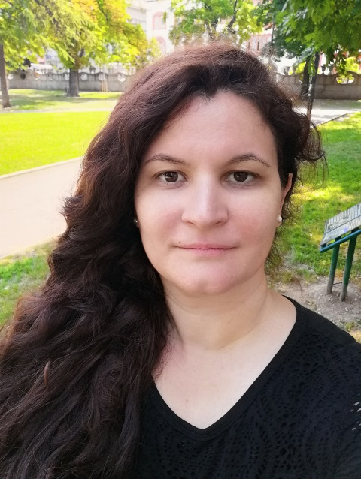
Curriculum Vitae
dr Aleksandra A. Rakić

Date and Place of Birth: 3rd September 1979., Kruševac

Home Address: Šejkina 60B, 11000 Belgrade, Serbia

Mobile: +381642060853 Email: saska@ffh.bg.ac.rs

Languages: Serbian (native), English (fluent), German (basic)

Interests: Hiking, Natural and traditional remedies, Science

promotion, Traveling, Bike riding, Swimming, Animal welfare
Publications:
Google scholar KoBSON Scopus Research gate
Research interests: polymers and nanomaterials
- Synthesis and computational treatment and application of polymer nanomaterials (conducting or non conducting, synthetic or biopolymers)
- Methods for characterisation and analysis of polymer materials: spectroscopy (FTIR, Raman, UV-Vis), electrochemistry, microscopy (SEM, TEM), XRD, XPS, adsorption methods
- Preparation of natural remedies and cosmetic recepies according to national tradition

Education

Faculty of Physical Chemistry, University of Belgrade, Serbia
2014. PhD theses defended: ''Polyaniline Nanostructures Synthesized By The Dopant-Free
Oxidative Polymerization of Aniline''
2008. Magister theses defended: ''Theoretical study of axially coordinated ligands in crystal
structures of porphyrin complexes''
2003. Bachelor theses defended: ''Global optimization and examples in molecular docking''

1998. Graduated in Medical secondary school
Work Experience
Faculty of Physical Chemistry, University of Belgrade, Serbia

from 2005. – Teaching assistant at courses:
Physical Chemistry, Mathematical Methods in Physical Chemistry, Practicum in Mathematics for Physicochemists, Computer Science and Programming 101, Information Technologies in Physical Chemistry, Introduction to Laboratory Practice, Physical Chemistry of Macromolecules, Solid State Physical Chemistry, Physical Chemistry for students of Biochemistry, Physical Chemistry 2 for students of Chemistry

from 2016. - Research assistant

Research projects
- Ministry of Education, Science and Technological Development of the Republic of Serbia- Fundamental research in periods: from 2011 to date (Project No. 172043.) , 2006 – 2010 (Project No. 142025.) and 2003 – 2005 (Project No. 1448).

